CSA-0307 CO 1 ASSIGNMENT -2
DATA STRUCTURES SAYYAD AHMAD ALISHA
(192525415)
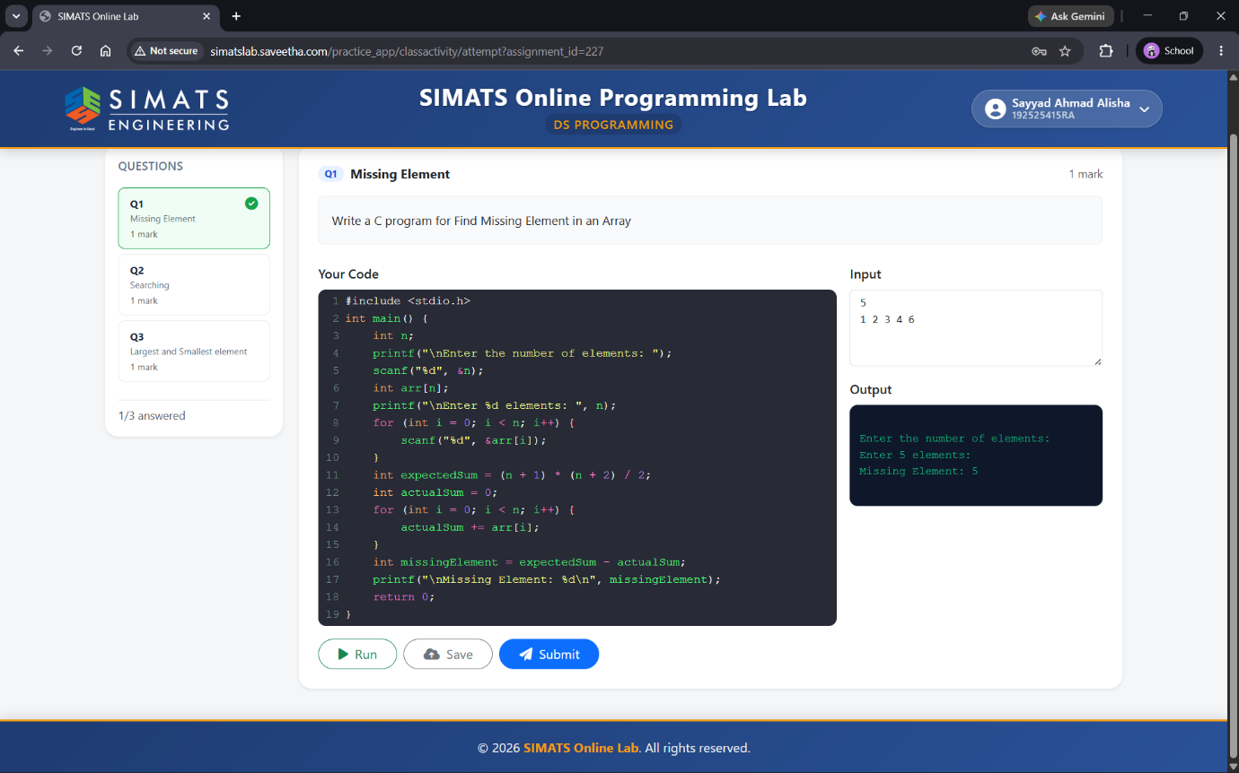
QUESTION -1 MISSING ELEMENT

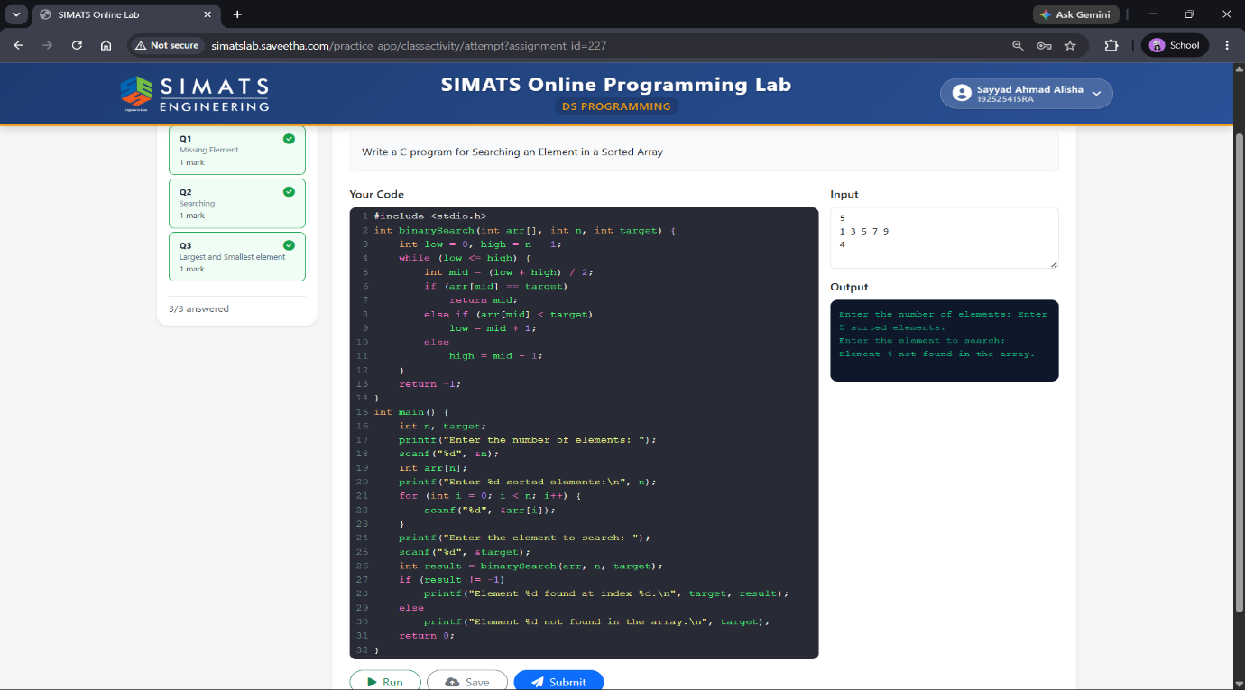
QUESTION 2 SEARCHING AN ELEMENT
QUESTION-3 LARGEST AND SMALLEST ELEMENT

